caAERS v1.0
End User Manual

Document Change History
Version Number | Date | Contributor | Description
V1.0 | June 12, 2007 | Jason Carmichael | Initial Template
V1.1 | July 29, 2007 | Jason Carmichael | Initial Draft based on Iteration v. 4
V1.2 | August 10, 2007 | Paul Galvin | Completed draft of Chapter 2 halfway through expedited report. 8 more section left in that, then move on to Routine reports.
V1.3 | August 16 | Paul Galvin | New format of the user guide based on tasks rather than modules.
V1.4 | August 24 | Paul Galvin | Redone with grammar and wording corrections.

Last Update: 8/27/07



Chapter 1 Introduction and Overview of Application 1
Introduction 1
Application Overview 1
Application Requirements 1
Features and Functions of the Application 1
Description of the User Interface 2
Getting Started 3
Logging On 3
System Menu 3
Exit System 3
Chapter 2 User Types and Tasks 3
System User Types 3
Principle Investigator 3
Study Coordinator 3
Study Administrator 3
System Administrator 3
Study Participant 3
User Tasks 4
Enter a Routine Report 4
Enter an Expedited Report 6
List Reports 9
Create a Study 9
Create a Participant 12
Importing Studies/Participants 13
Search Study 14
Assign a Participant to a Study 15
Create Rules 17
Create Report Definition 21
List Rules 23
List Report Definitions 23

Copyright and License page

Project Management
Project Manager | Edmond Mulaire, Ph.D., PMP | SemanticBits | edmond.mulaire@semanticbits.com
Functional
Team Lead/POC | Warren A. Kibbe, Ph.D. | Northwestern University | wakibbe@northwestern.edu
Team Lead/POC | Cal Collins | Akaza Research | ccollins@akazaresearch.com
SME/Principle Investigator | Renee Webb, MA, CCRC | Northwestern University | r-riphenburg@northwestern.edu
SME/QA Lead | Natasha Ganzenko, MD | Northwestern University | n-ganzenko@northwestern.edu
SME/Sr Data Coordinator | Brenda Martone, RN | Northwestern University | b-martone@northwestern.edu
 | David Patton | Northwestern University | d-patton2@northwestern.edu
Technical
Lead Architect | Vinay Kumar | SemanticBits | vinay.kumar@semanticbits.com
Lead Developer | Joshua Philips | SemanticBits | joshua.philips@semanticbits.com
 | Rhett Sutphin | Northwestern University | r-sutphin@northwestern.edu
Developer | Krikor Krumlian | Akaza Research | kkrumlian@akazaresearch.com
 | Sujith Thayyilthodi | SemanticBits | sujith.thayylithodi@semanticbits.com
 | Padmaja Vedula | SemanticBits | Padmaja.vedula@semanticbits.com
Analyst | John Osborne | Northwestern University | j-osborne@northwestern.edu
UI Designer | Richard Jenkins | Akaza Research | rjenkins@akazaresearch.com
Technical Writer | TBD | Akaza Research

Contacts and Support
Edmound Mulaire | edmond.mulaire@semanticbits.com
caAERS project Site | http://gforge.nci.nih.gov/projects/caaersappdev/  Telephone:  Toll free:

LISTSERV Facilities Pertinent to software teams
LISTSERV | URL | Name
Caaers-Developers | Caaersappdev-developers@gforge.nci.nih.gov | caAERS Developers Listserv
Caaers-Domain | Caaersappdev-developers@gforge.nci.nih.gov | caAERS Domain Listserv
Caeers-Technical | caaersappdev-technical@gforge.nci.nih.gov | caAERS Technical Listserv

Introduction and Overview of Application

Introduction
T.B.W.

Application Overview
The caAERS application is an open source, standards compliant application designed to manage adverse events in cancer clinical trials. This system enables multiple users to access, report and query Adverse Events (AE) and Serious Adverse Events (SAE) from a web enabled browser.

Application Requirements
Client Minimal System Requirements
- Internet connection
- Firefox 1.5 or higher or Internet Explorer 6
- A valid caAERS application server URL

Features and Functions of the Application
T.B.W.

Description of the User Interface

The caAERS User Interface is built on Java based software and supported by an Oracle or Postgres database. This application allows a user to enter clinical study information and report adverse events. The following diagram illustrates the caAERS system workflow and relation to external systems. All bolded boxes are workflows associated with the caAERS system.

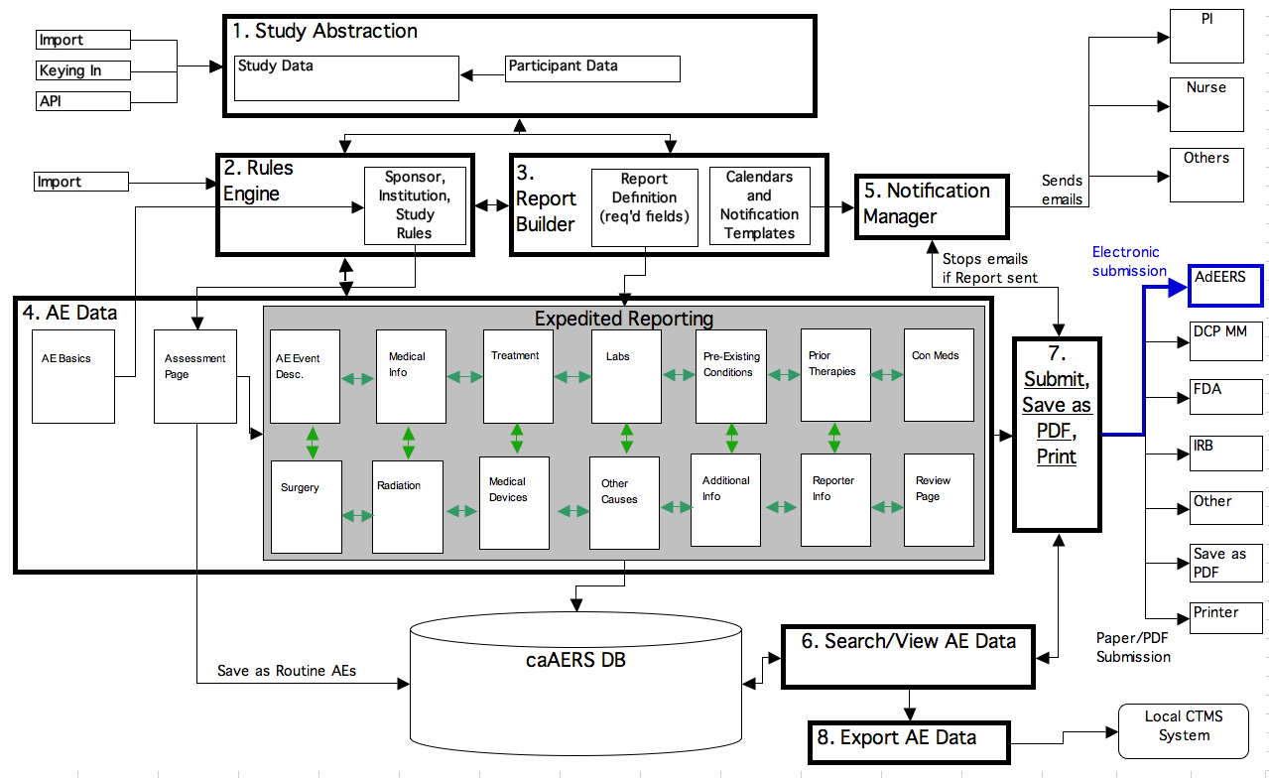
Standard Interface Components:
Navigation Menu: The Top Navigation menu allows access to any module. Click on the appropriate title to review/modify the section.
Workflow: Allows user to access completed sections within a module.
In-line help: Selecting the help icon adjacent to a form field reveals corresponding help information.
Help Index: Located in the top right hand corner, provides an index of help context.

Getting Started

Logging On
Users can login the caAERS system by entering a valid username and password. Once these values are entered in the correct fields, click the login button. If the username or password is invalid the message, “Incorrect username and/or password. Please try again” appears above the username/password fields.

System Menu
The caAERS system can be easily navigated using the top navigation menu. Users can access the top level system modules: Adverse Events, Studies, Participants, Reports, Rules, Administration and Advance Search from any page within the application. To access these modules click on the appropriate navigation bar link.

Exit System
To exit or logout of the caAERS system, click the logout link located in the top right hand corner.

User Types and Tasks

System User Types

Principle Investigator
The Principal Investigator of a clinical trial.

Study Coordinator
The individual responsible for setting up the study in the system, creating the protocols, defining adverse events in the system and generally setting the parameters of a study.

Study Administrator
The user responsible for entering in adverse events as they occur

System Administrator
This user is responsible for maintaining the caAERS software.

Study Participant
A qualified patient enrolled in a study.

User Tasks

Enter a Routine Report
As a user of the caAERS application, you can enter a routine adverse event report by providing information for a participant and the study the participant is a part of. As information is entered into each field on the page, the system will provide a list of matching criteria as seen below.

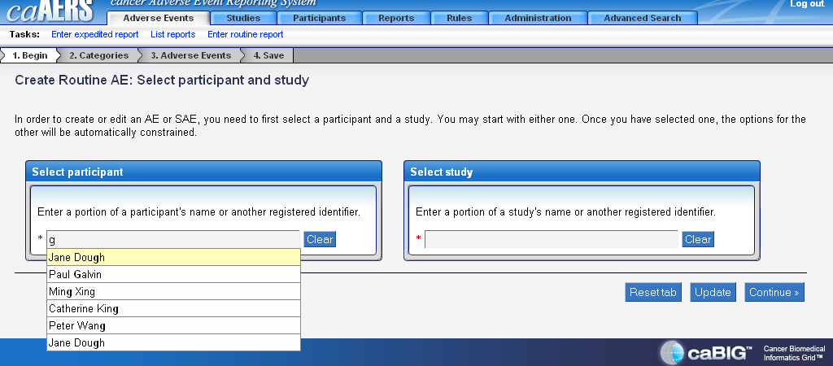

Select the participant and move on to enter the study’s name. Or, enter the study first and then the participant. The study field will act in the same way as the participant field as shown in the screen shot above. The system will show the selection at the bottom of the each field so if it is not correct, hit the Reset Tab button. If everything is selected correctly, select the Continue button.

The next step is to enter information related to the category of the adverse event that has occurred. The category will be determined by the data dictionary the study is using. If the study is using CTC terminology, the CTC categories will be shown. If the study is using MedDRA for its terminology, the MedDRA categories will be displayed for the user to choose from. Below is a screenshot of the CTC categories.
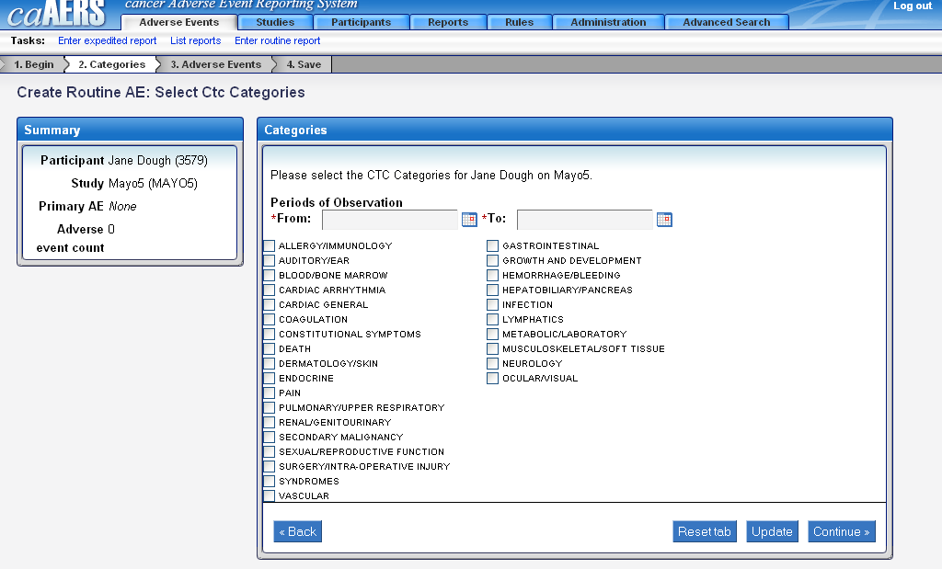

Select the appropriate categories for this adverse event and also enter a date range the event occurred in. To provide the user a snapshot of what they are working on, a summary box will appear with information about the participant, study and the adverse event count in the upper left hand corner of the page. After the information has been entered and selected, hit the Continue button to move on. If there is a need to go back a page, hit the Back button. To reset the page to a blank state, click Reset Tab, and to save the page and not move forward, click the Update button.

The next page you will see is asking for the Term, Grade, Attribution, Hospitalization, and whether it was an expected adverse event. In order to complete this page, click on one of the categories, then select a sub-category, and hit the green plus sign to the right of the sub-category.
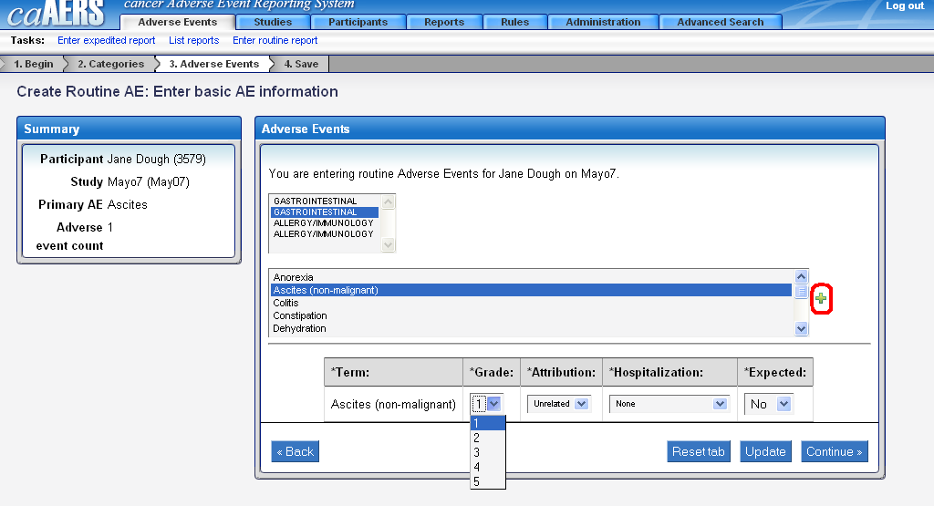

As soon as the sub-category is selected, the options to select the Grade, etc. for the adverse event will be shown. The information will be contained in a drop down box with restricted terms available to choose from. After this page is completed, hit Continue to see the following page.

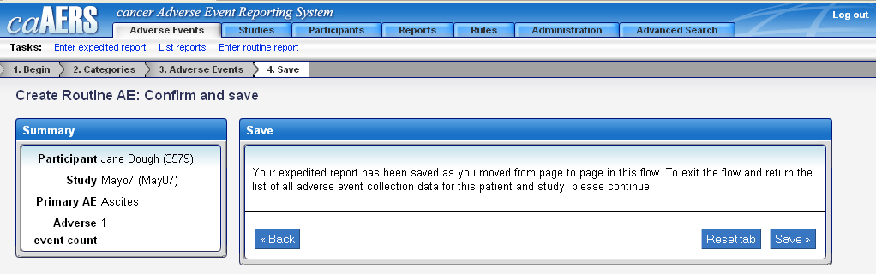

A message appears saying the information has been saved as you went through each screen in the process flow. To view all of the adverse events for the participant, the user can hit the Save button. If the user enters any information that triggers the system to force the user to enter an expedited report, there will be additional information required.

Enter an Expedited Report
An expedited report must be entered for serious adverse events. Either the system will force the user to enter an expedited report or the user can choose to enter an expedited report on the own. The process begins the same way as creating a routine report by choosing a participant and a study.

Depending on the dictionary of terms chosen when the study was created in caAERS, the user will be asked to provide information for CTC or for MedDRA. The page will look like the one shown below.

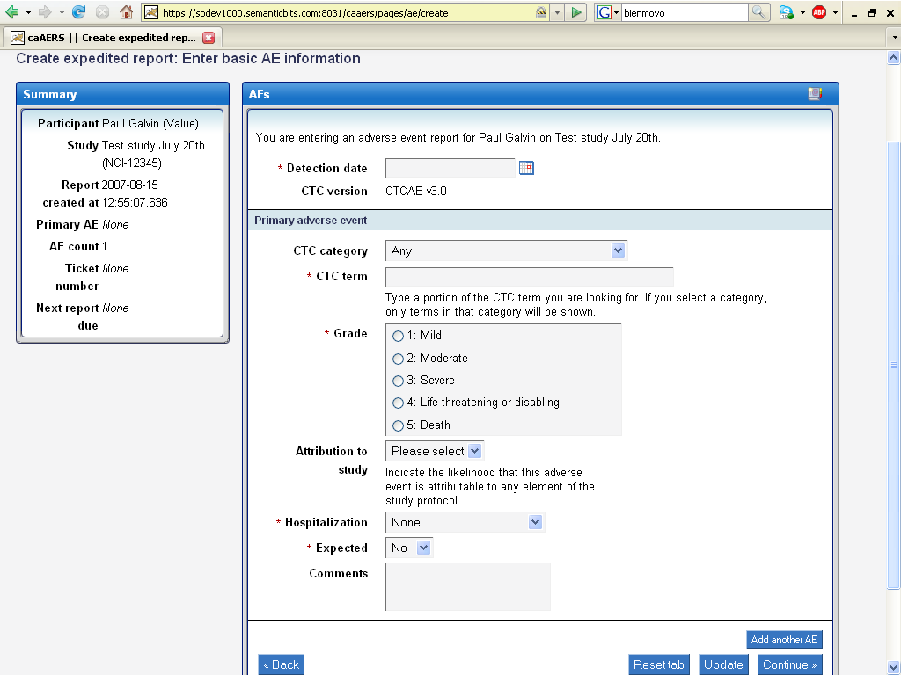

Again, depending on the terms being used in the study the user is going to see the CTC version or the MedDRA version. If more than one AE has occurred, the user can click on the Add another AE button to get another one of the forms to fill out. The user will have the option, like in other screens throughout the application to go Back, Reset tab, Update, or Continue.

If a study is using pre-determined rules for submitting an expedited report, it will be shown to the user. The user will also have the option of submitting the report based on other rules that have been set up with their instance of caAERS. Just click the checkbox next to the other reports you want to submit.
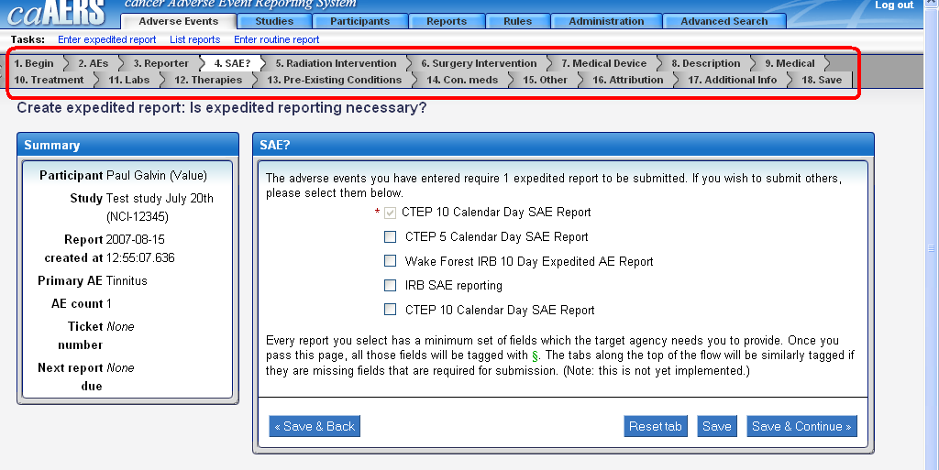

At this point, to continue select Save & Continue or Save to move on to other pages of the expedited report. Or, if there is no need to enter any data into the Radiation Information tab, Surgery Intervention tab, or the Medical Device tab, etc. click on the Description tab to go right to that part of the form. The tabs can be seen in the red highlighted area above.

The rest of the tabs will have either optional information or required information. If the user tries to move past a field with required information the system will display an error message to ensure you do populate the field. For example, if you decide to add data for lab information for a participant, you must provide the Lab Test Name and the Lab Units. If they are left blank, the following error messages will be displayed.

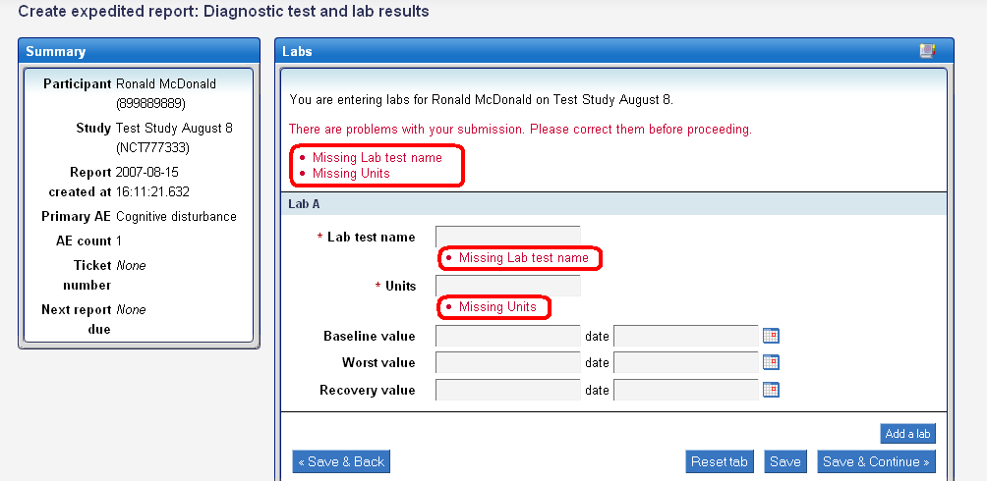

The only way to move past this page of the expedited report is to provide the missing information.

List Reports
The user of caAERS can view every report for a particular participant, or a particular study in one simple screen. They do not have to navigate to look at a report of expedited reports, and then move to another screen to see the routine reports. By entering the some of the letters of the participants name and clicking Continue, or entering some of the information for the study and clicking Continue, the user can see all of the reports associated with the particular patient or a complete study.

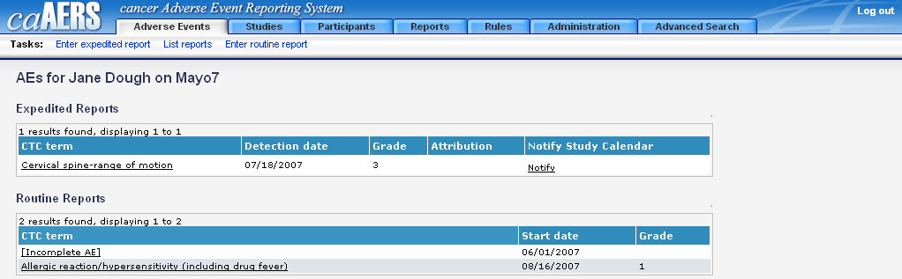

Where appropriate, the user can choose to notify the Study Calendar by clicking on the link under the Notify Study Calendar heading. Also, the user can look more in depth at the expedited reports or the routine reports as a link is provided on the page that can be selected to get more information.

Create a Study
A study can be created in two different manners, one is by importing the study data from an external database, and the other is to go through different screens and supply the necessary information.
Creating a study from scratch in caAERS is very simple. Information needs to be supplied in seven different pages before it can be saved for future use and allow participants to be added to it.

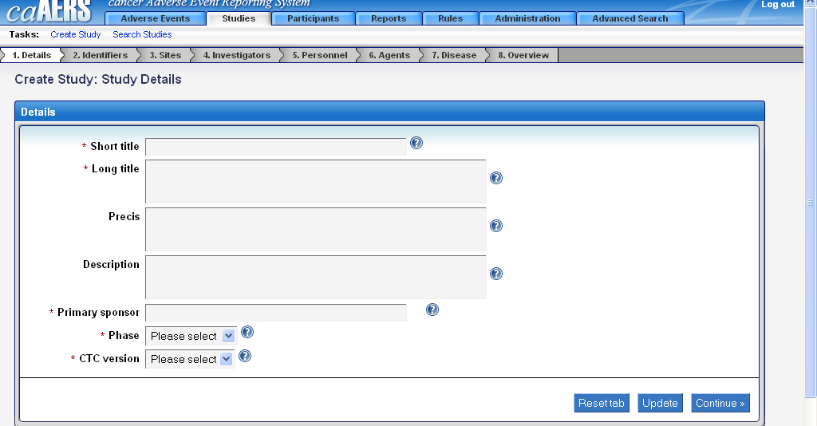

The user must enter information in all of the required fields before you can move on to the next form to fill in additional information. The information will need to be supplied by typing in the values, or selecting certain values from a drop down box.

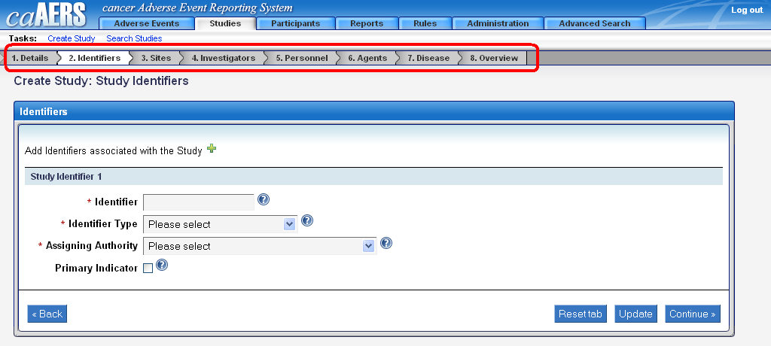

The bar at the top of the screen shows sub-tabs that detail the step the user is on in the process so they can see how much is left to do. Information can also be provided in the optional fields. This information will provide a better description and help other users of the caAERS application to identify a study more readily.

As each form is populated, hit Continue to move on to the next form in the process. If the user does not want to move forward but just save the information, hit the Update button. If the user begins to enter information and realizes it is wrong, the information can be reset to its original state. This can be done by hitting the Reset Tab button.

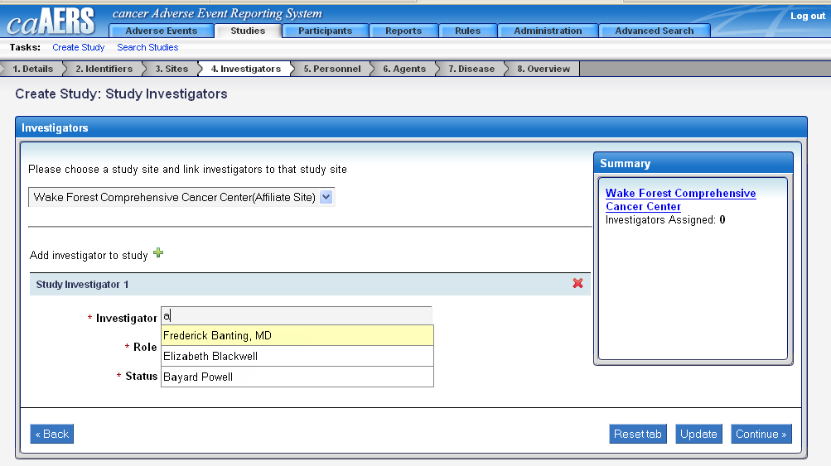

When choosing the investigators for the site, you can choose more than one. However, if more than one investigator is chosen, at least one investigator must be selected as the primary investigator. By clicking on the green plus sign the user can add a field to put another investigator on the study. If the user adds one by mistake, hit the red “x” to remove the fields.

Continuing on, you can select the research staff that will be working and assisting with the study as well. Again, the page will look exactly the same as the previously mentioned screen shot where you will need to select personnel and decide if you need to add more or not.

Agents and Diseases for the study also need to be provided. The agent is not required, but if you choose to add one there will be some required fields. There can be multiple diseases studied in the trial and the application will provide you a snapshot of everything you have chosen. If for some reason a disease was added incorrectly, it can be removed. The following screenshot provides a visual of what the disease selection tab will look like.
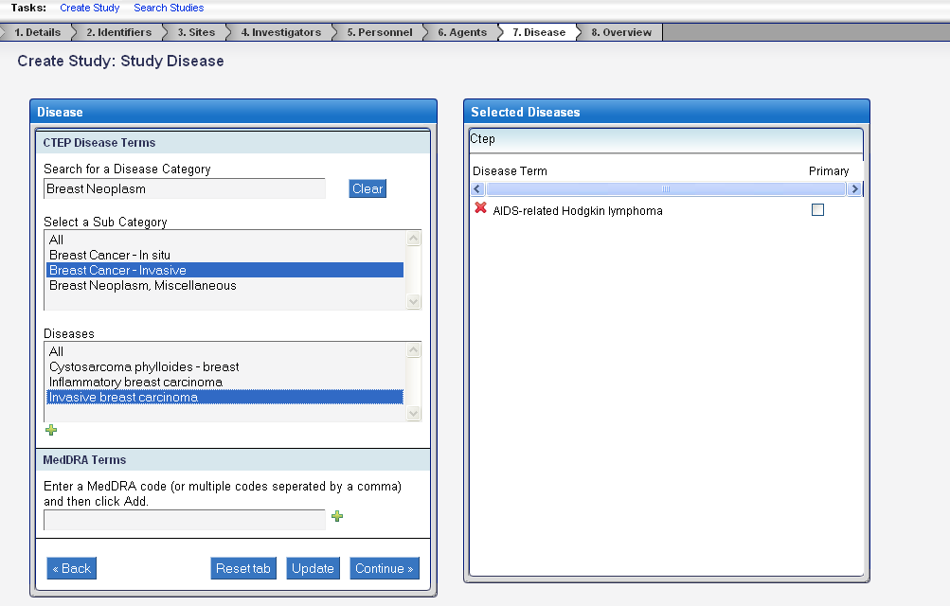

Create a Participant
Participants can be added in a similar fashion to studies. The user can either manually enter a participant into caAERS or they can import a file into the application to add a participant. To enter a participant manually, six required fields need to be populated.

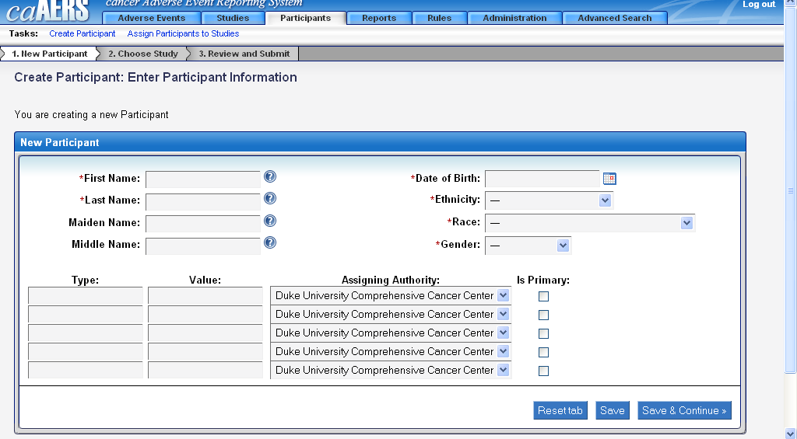

Once the information has been entered for the participant, you will need to assign them to a study. The user can search for a study by the Short Title, Long Title, or one of the Identifiers given to the study when it was created. Hit the Go button and caAERS will provide a list of all the matching studies.

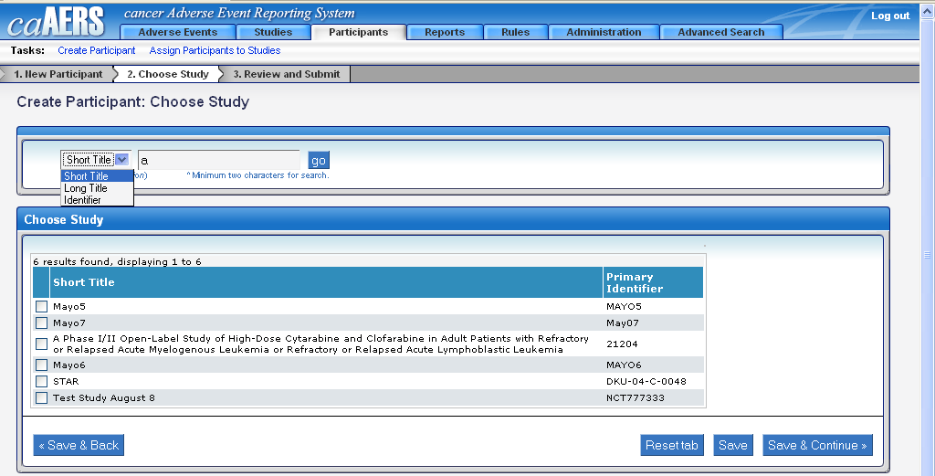

The user will need to select one of the check boxes next to a study to assign the participant to it. After you hit Save & Continue, you will get a chance to review the information before saving it one final time.
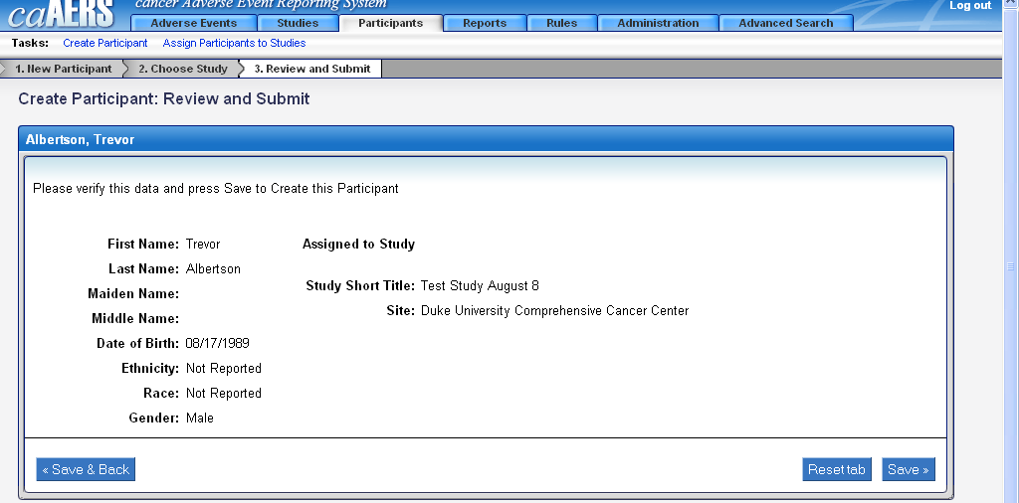

Importing Studies/Participants
Studies and Participants can be added to caAERS in a quicker fashion if they have already been created in another application. As long as the information has been saved in a certain format as detailed in the Administration guide, it can be uploaded into caAERS without the user having to go through multiple screens.

Within the Administration module there is a link to Import. Clicking on this link will bring you to a page where you can choose to import a Study/Protocol or Participant.

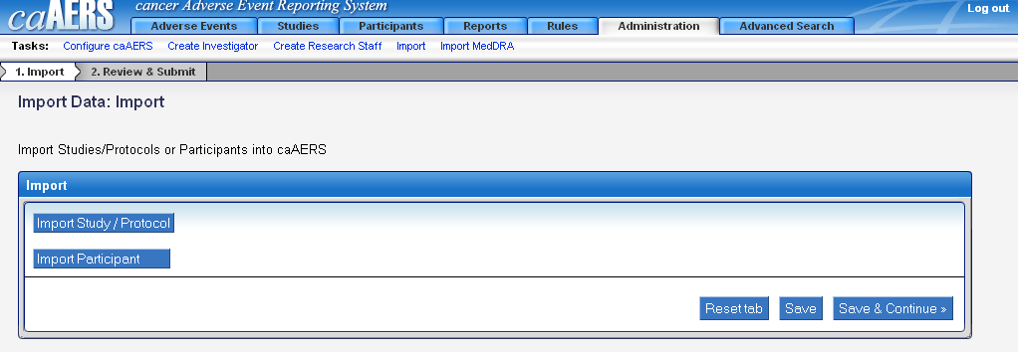

Selecting either option will bring up a box with a Browse button to the right of it. Click on the Browse button and you will be able to navigate to the folder that contains the file you want to import. This process is just like attaching a file to an email before sending it.

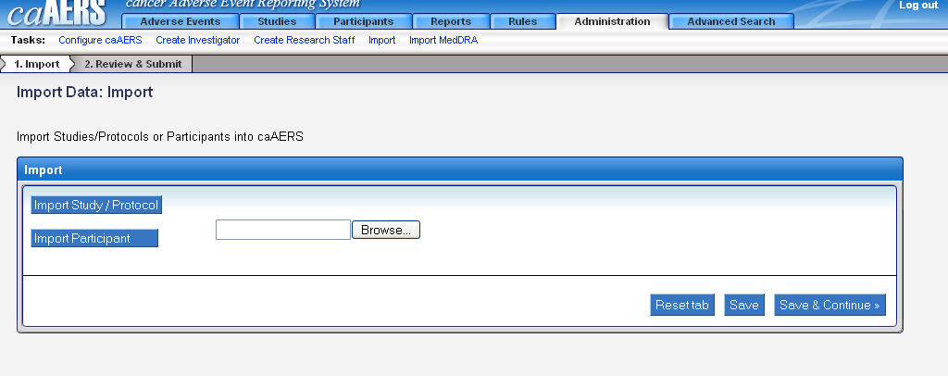

Search Study
The user can search for studies to see if they are part of their caAERS instance. In the Study module is a link called Search Studies. Click on this link and you will be provided a search box that can be used to find a study by Short Title, Primary Identifier, or Status.

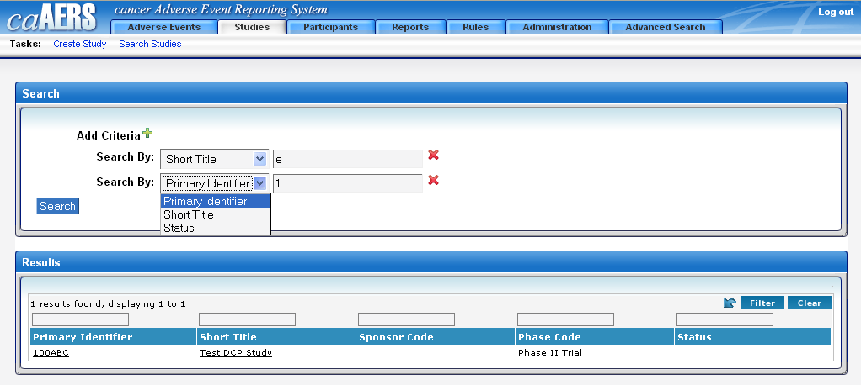

The user can search with multiple criteria being selected. The way to do this is to click the green plus sign. Once the search button has been selected it will provide a list of all the studies meeting the criteria you searched on. Click on the Short Title or Primary Identifier to view the study’s information.

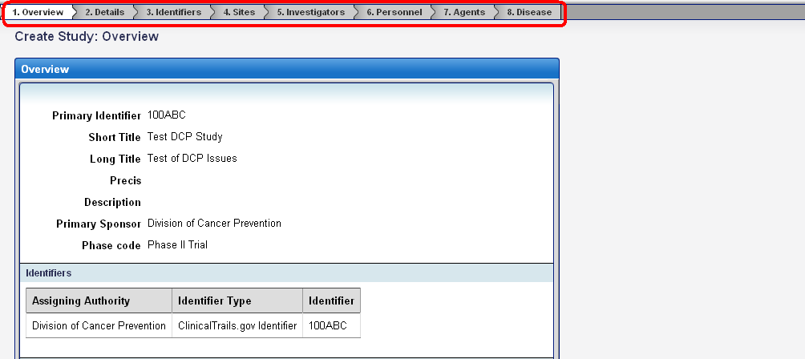

The user can quickly navigate to where they want to by clicking on any of the tabs at the top of the page. This information will be read only.

Assign a Participant to a Study
In caAERS, a user can assign a participant to a new study. The user can take two different routes to accomplish the exact same result. In the Participants module is a link called Assign Participants to Studies. Clicking on this link will provide the following page.

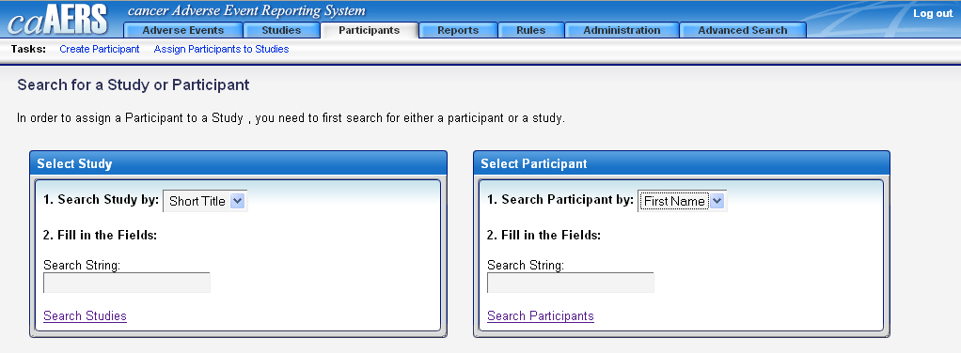

The user can start by searching for the study, or we can start by searching for the participant. If you decide to search for the participant first you will need to enter some data into the search string, and then hit Search Participants. The next page will show a list of all the participants matching the search criteria.

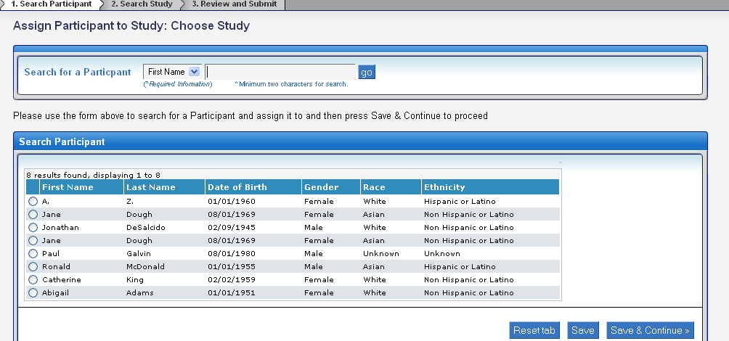

One of the participants must be selected or another search can be run if you can not find the participant you were looking for. Once the participant has been selected, hit the Save & Continue button to choose the study you want to assign the participant to.

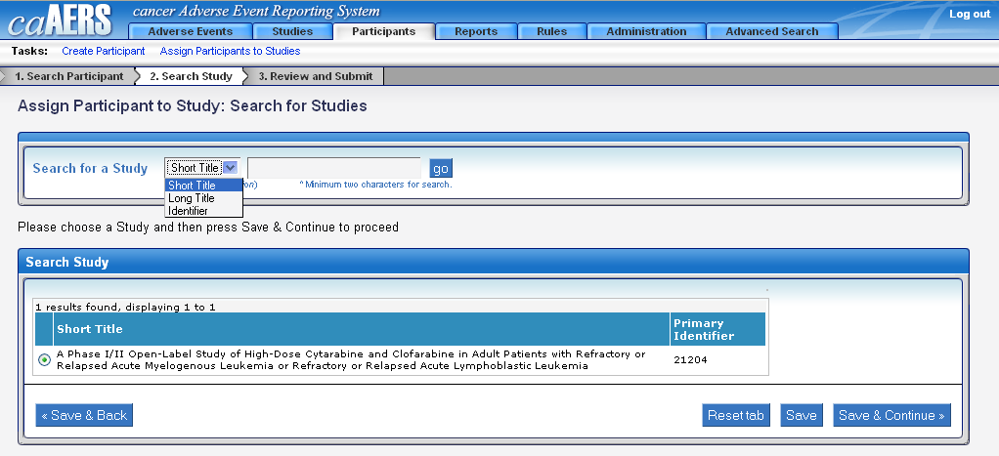

After hitting Save & Continue, the application will provide a summary screen of information related to all the actions you just took. To permanently move this participant to the study hit Save.

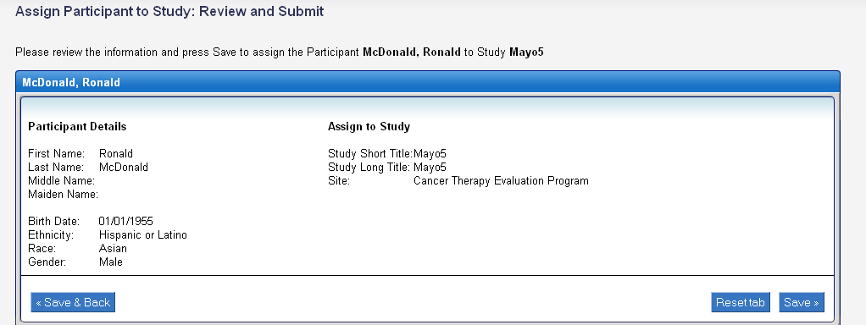

The order of steps taken would be reversed if the user wanted to look for the study first, but the information shown in the screenshots would be exactly the same.

Create Rules
Rules are needed to determine what course of action the system should take when an Adverse Event is logged in the system. Rules can be created at four different levels, the Sponsor level, the Institution level, the Sponsor Defined Study level, or the Institution Defined Study level by clicking on the radio button next to the level of choice.
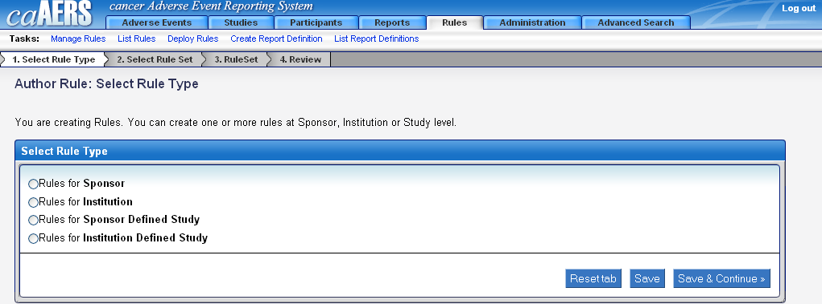

If you select Sponsor Defined Study or Institution Defined Study, you must populate two fields rather than one before hitting Save & Continue.

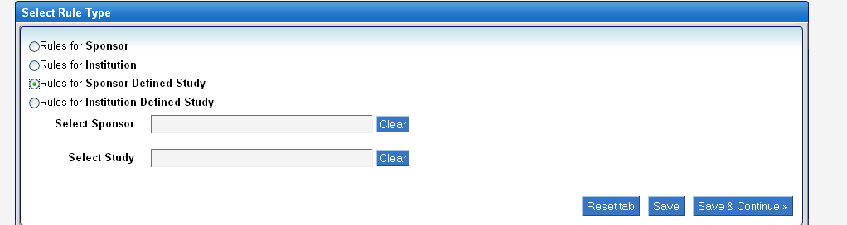

When entering information into the fields, a list will automatically populate with names of the Sponsor or Study, depending on what you select. The next page will ask you to create a ruleset.

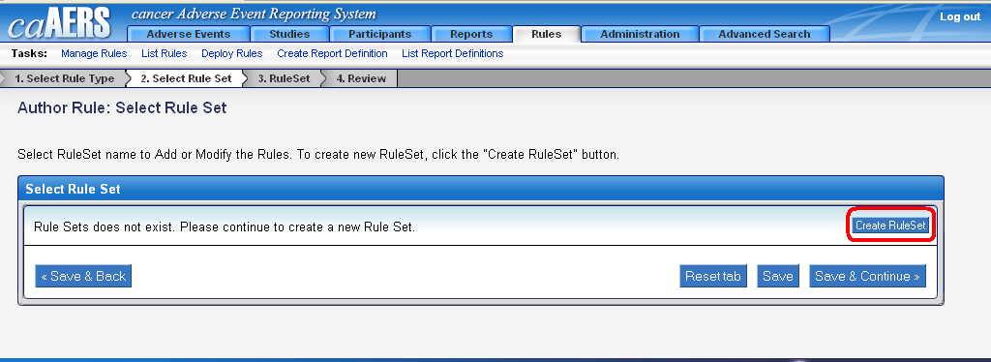

Select the create ruleset button highlighted above to select a Ruleset name.

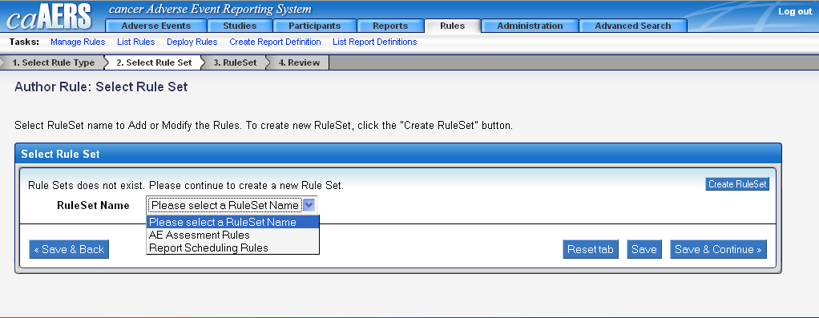

The following screen will require you to hit the Add Rule button in the right hand side of the page.

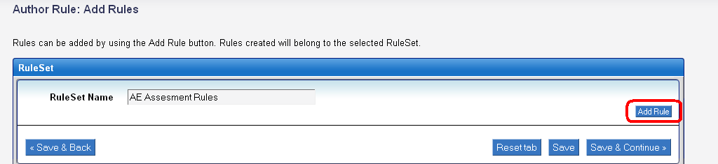

After the Add Rule button is selected, a form will appear below the Ruleset Name with some information that needs to be chosen. The information is going to be different conditions, that when met, an expedited adverse event report must be completed.

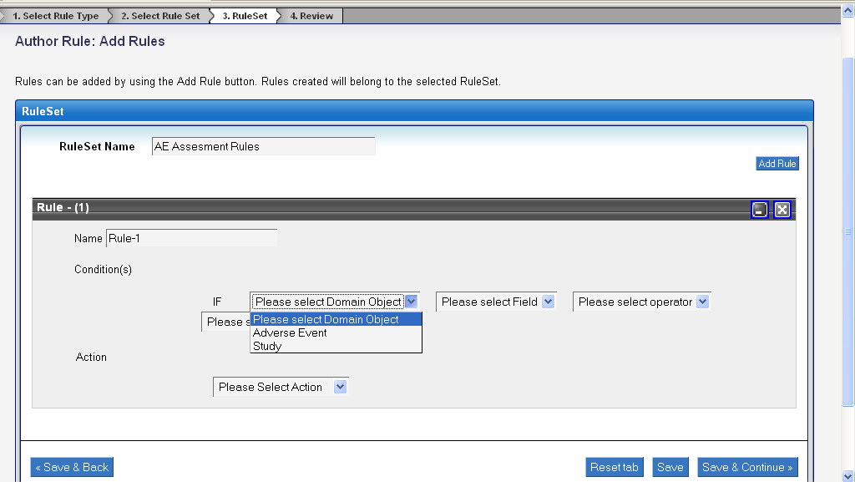

The first step is to select what is called a Domain Object, which will either be Adverse Event or Study. The next selection of fields is going to change depending on what type of Domain Object you select. If Adverse Event is selected the following table will appear in a drop down list.

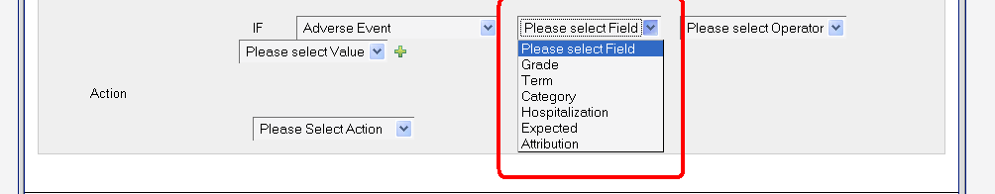

If Study is selected, this is what you will see.

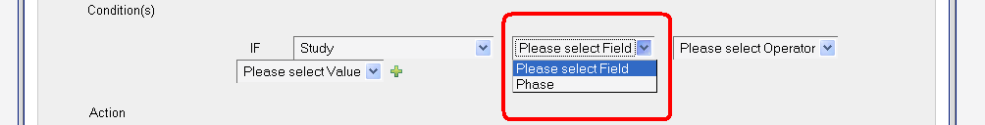

As you continue on, the fields will change with each of the selections you make. The operator will have at least two selections of Equal to or Not Equal to.
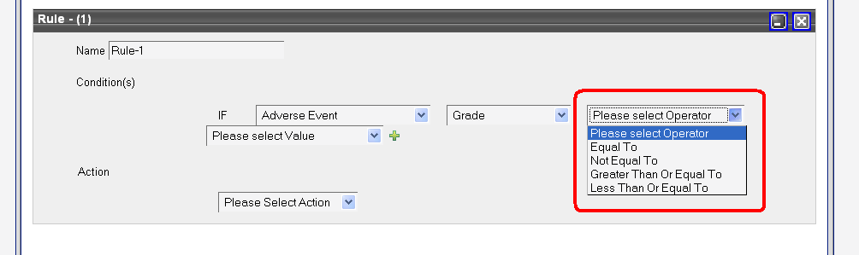

Multiple conditions can be set so you can have If/And statements covering different Terms, or Grades, or Expected etc. Just click on the green plus sign to add a condition to a rule, or click the red X to remove that condition.

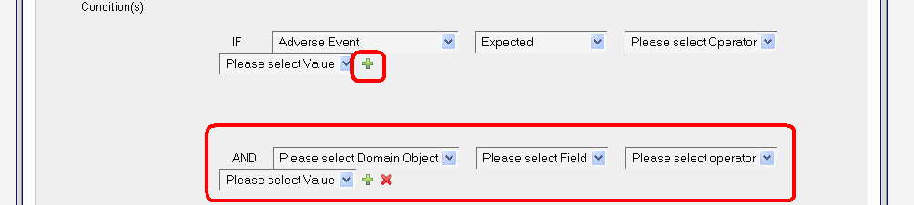

After hitting Save & Continue you can review the information provided by clicking on the tabs at the top of the screen before saving them. If everything looks good, hit Save.

Create Report Definition
Creating a report definition is accomplished in only one screen. There will be a total of five fields, with four of them being required. As soon as you type in some information into the fields it will automatically show a list of results matching what was typed in.
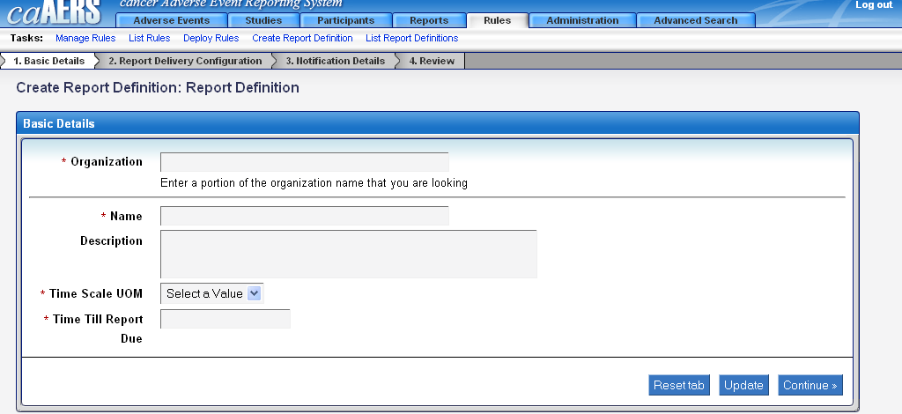

Once the information has been populated and you have hit Continue, you will be asked to set up a recipient of this report. The recipient can be set up as a System/Person or as a Person-Role. Click the button to add the appropriate recipient, and the following screen will appear.

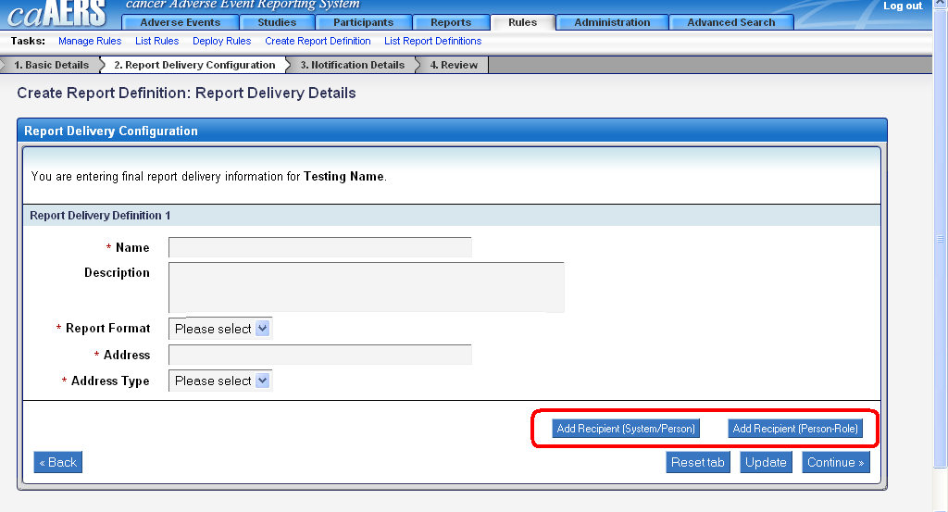

Populate the required fields, and the optional field if appropriate, and click Continue. The next step is to set up a schedule of when the report will be sent, and what email address the report will be sent from. A message can be included in the emailed report being sent.

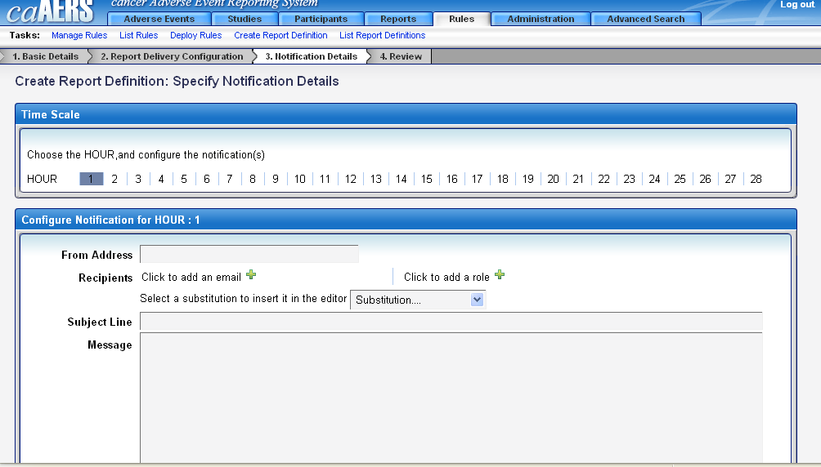

List Rules
You can choose to look at all of the rules currently created in the caAERS application by clicking on the link called List Rules in the Rules module. The following screen will appear and you can then choose to deploy the rules by clicking on the link at the right of the table. Also, you can get more information about the rule by clicking on its hyperlink.

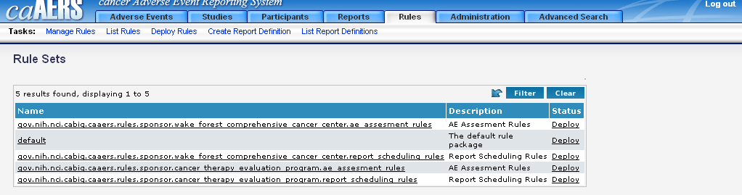

List Report Definitions
You can choose to look at all of the report definitions currently created in the caAERS application by clicking on the link called List Report Definitions in the Rules module. The following screen will appear and you can then choose to get more information for a report definition by clicking on its hyper link.

